Motichand Lengade Bharatesh Polytechnic,
BELAGAVI

Computer Science & Engg
2nd Internal Test

Project Name :
USB Security Key

Guide :
Sheethal Dharwadar (H.O.D)

Group Members :
1. Manojkumar Patil (315CS20012)
2. Vinayak Kamkar (315CS20048)
3. Vishal Kadalagi (315CS20049)

Description of Technology Used
- USB Connector: A USB connector is used to connect the USB Security Key to a computer or other device that provide authentication and cryptographic capabilities. These tokens store encryption keys, digital certificates, and user credentials in a secure, tamper-resistant environment. They enable strong authentication and help verify the identity of users before granting access to USB devices.
- Non-volatile memory: A USB Security Key typically contains non-volatile memory, such as EEPROM or flash memory, to store security keys and other authentication data.
- Cryptographic algorithms and protocols: Cryptographic algorithms and protocols are used to ensure the security and integrity of the authentication process. These may include algorithms such as RSA or AES, and protocols such as U2F or FIDO2.
- Encryption Algorithms: Encryption algorithms are fundamental to USB security systems. They are used to encrypt the data stored on USB devices, making it unreadable without the appropriate decryption key. Advanced encryption algorithms such as AES (Advanced Encryption Standard) are commonly employed to provide robust data protection.
- Access Control Mechanisms: Access control mechanisms are implemented to regulate and restrict access to USB devices. This can involve user authentication through passwords, PINs, biometric identification (fingerprint or facial recognition), or the use of cryptographic keys stored on USB tokens. Access control ensures that only authorized individuals can use or access the USB devices.

Details of Hardware Devices
- USB Security Key
USB security keys are primarily used for two-factor or multi-factor authentication (2FA/MFA). They add an extra layer of security beyond traditional usernames and passwords by requiring users to physically possess the USB security key and enter a PIN or provide biometric verification.
2. Client PC
It is a normal Computer or Laptop, but only the specified User can use it. Client PCs serve as the primary computing devices for individuals, providing them with the tools and resources necessary to perform tasks, access information, and engage in various activities. The specifications and capabilities of client PCs can vary based on user requirements, ranging from basic systems for everyday tasks to high-performance machines for demanding applications like gaming or professional workloads.

Programming Languages:
- Python
General-Purpose Language: Python is a general-purpose programming language, which means it can be used to develop a wide variety of applications, ranging from web development and data analysis to artificial intelligence and scientific computing.
Python has a clean and easy-to-understand syntax, making it beginner-friendly and suitable for rapid development.
It emphasizes code readability by using indentation and a straightforward syntax structure. Python is an interpreted language, meaning that the Python interpreter executes the code line by line. This allows for interactive development and quick prototyping.

Tkinter (Python)
Tkinter is a Python library for creating graphical user interfaces (GUIs). It is a standard library that comes pre-installed with most Python distributions, making it easy to use for developing GUI applications.

Tkinter is a popular choice for creating simple to moderate GUI applications in Python due to its simplicity and ease of use. However, for more complex or specialized GUI requirements, other libraries like PyQt or wxPython might be preferred.

Tkinter is included with standard Python distributions, which means you don't need to install any additional packages to use it. It provides a Python interface to the Tk GUI toolkit, which is widely used for GUI development.

- MySQL

A MySQL is a relational database management system (RDBMS) developed by Oracle that is based on structured query language (SQL). A database is a structured collection of data

MySQL is an open-source relational database management system (RDBMS) that is widely used for managing and storing structured data. Here are some key details about MySQL

Relational Database Management System: MySQL follows the relational model of organizing data, where data is structured into tables with rows and columns. It allows you to define relationships between tables, enforce data integrity through constraints, and perform operations using SQL (Structured Query Language).

Open-Source: MySQL is an open-source software, which means it is freely available for use, modification, and distribution. It has a large and active community of developers contributing to its development and maintenance.

Cross-Platform Compatibility: MySQL is designed to work on various platforms, including Windows, macOS, Linux, and more. This cross-platform compatibility allows you to deploy and run MySQL databases on different operating systems.

Scalability and Performance: MySQL is known for its scalability and performance capabilities. It can handle large amounts of data and concurrent users efficiently. It supports various optimization techniques, indexing, and caching mechanisms to optimize query execution and improve performance.

Descriptions of Components in the System
- USB Security Key: The USB security key itself is a physical device that acts as a cryptographic token and is used for authentication. It contains a microcontroller or secure element that securely stores cryptographic keys and performs cryptographic operations. The key may include a USB interface for connecting to a computer or other devices.

- Cryptographic Algorithms: The USB security key relies on cryptographic algorithms to ensure secure communication and authentication. Commonly used algorithms include symmetric encryption algorithms (e.g., AES), asymmetric encryption algorithms (e.g., RSA), hash functions (e.g., SHA-256), and digital signature algorithms.

- Firmware: The firmware is the software that runs on the microcontroller or secure element within the USB security key. It handles cryptographic operations, implements authentication protocols, and manages communication with the host device.

- Authentication Protocols: The USB security key project may involve the implementation of various authentication protocols. These protocols define the communication flow and steps required for secure authentication between the USB security key and the host device
It's important to note that the specific components used in a USB security key project can vary depending on the project's requirements, desired security level, and the chosen authentication protocols. Additionally, other components such as secure databases, key management systems, and backend servers may be involved in more complex deployments.
Component Diagrams and Designs
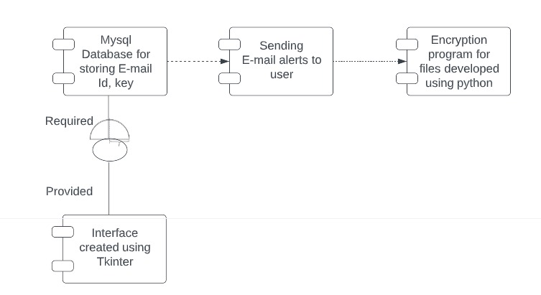

A component represents a modular and independent part of a system that encapsulates related functionality. It represents a physical or logical unit that can be replaced, deployed, or modified independently. Components are depicted as rectangles with the component name written inside.

An interface defines the contract or set of operations that a component provides or requires. It specifies the methods or services that can be accessed by other components. Interfaces are depicted as labeled connectors between components, indicating the required or provided interfaces.

Construction and Fabrication Details

- Enclosure: The USB Security Key is typically enclosed in a protective casing, which may be made of plastic, metal, or other materials. The enclosure helps protect the device from damage and may also be used to display branding or product information.

- USB Connector: The USB connector is used to connect the security key to the client device, allowing it to interact with the device and perform its authentication functions. The USB connector may be mounted directly on the circuit board or attached to a cable that connects to the board.

- Cryptographic Algorithms: Cryptographic algorithms are used to secure the authentication process and protect the user's data. These algorithms may include symmetric and asymmetric encryption, hashing, and digital signatures. The cryptographic algorithms may be implemented in software on the microcontroller or may be implemented in dedicated hardware components, such as a secure element or a cryptographic co-processor.

- Firmware: The firmware is the software that runs on the microcontroller and controls the operation of the security key. It may be programmed in a variety of programming languages.

- Authentication Protocols: The USB security key project may involve the implementation of various authentication protocols. These protocols define the communication flow and steps required for secure authentication between the USB security key and the host device

- Operating System Integration: To enhance security, the USB security key project may involve integration with the operating system. This integration can provide features such as secure key storage, system-level authentication, and cryptographic APIs for secure communication between applications and the USB security key.

- Software Development Kits (SDKs) and Libraries: Depending on the project requirements, software development kits (SDKs) and libraries may be used to simplify the development process. These SDKs and libraries provide pre-built functions and APIs for interacting with USB security keys, handling authentication protocols, and managing cryptographic operations.

It's important to note that the specific components used in a USB security key project can vary depending on the project's requirements, desired security level, and the chosen authentication protocols. Additionally, other components such as secure databases, key management systems, and backend servers may be involved in more complex deployments.

Any other information needed to execute python project
- Required Libraries and Dependencies: Identify the necessary Python libraries and dependencies needed for your project. These can include libraries for USB communication, cryptography, authentication protocols (such as FIDO U2F or FIDO2/WebAuthn), and any other specific functionality required by your project. Ensure you have the required versions installed and properly configured.

- USB Communication: Understand the USB communication protocol and specifications that your USB security key uses. This includes the USB device class, descriptors, and commands necessary for interacting with the key. You may need to use Python libraries like pyusb or libusb to communicate with the USB device at a low-level.

- Cryptographic Operations: Familiarize yourself with the cryptographic operations required for the USB security key project. This can include key generation, encryption, decryption, hashing, and digital signatures. Python provides several libraries, such as cryptography and pycryptodome, that offer various cryptographic functions and algorithms
.
- Authentication Protocols: If you are implementing authentication protocols like FIDO U2F or FIDO2/WebAuthn, study the specifications and standards associated with those protocols. Understand the steps involved in the authentication process, the required data formats, and how to verify and generate authentication responses. There are Python libraries like pyu2f and python-fido2 that can assist with implementing these protocols.

- User Interface (if applicable): If your Python project involves a user interface for interacting with the USB security key, consider using a GUI library like Tkinter or PyQt to create the interface. Design the necessary forms, buttons, and input fields to handle authentication requests, display status information, and perform relevant operations.

- Error Handling and Logging: Implement proper error handling and logging mechanisms in your Python project. Capture and handle exceptions, validate user inputs, and log relevant information to facilitate troubleshooting and debugging.

